

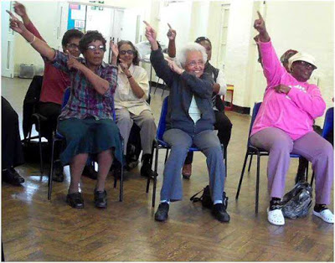

**JOIN US, EVERY TUESDAY**

**11.30am – 2.00pm**

**AT**

**Perivale Community Centre, Horsenden Lane South, UB6 7NP.**

**PROGRAMME OF ACTIVITIES**

**11.30-12PM: Social, Quiz and Services update.**

**12.00-12.30PM: Exercise Class group 1-spaces are limited.**

**12.35-12.45PM: Social, Quiz and Services update**

**12.45-1.15PM: Exercise Class group 2-spaces are limited.**

**1.30 -2.00PM: Bingo and quiz**





**For more information please contact us on 0208 566 4035. The office is open Monday to Friday from 10am-4pm. Please note spaces are limited and need to be booked in advance.**



**Neighbourly Care Founded: 1983  
1 Bayham Road, Ealing W13 0TQ Chief Executive: Peter Clarke**

**Tel: 020 8566 4035 Facebook: Neighbourly Care  
Email: ncenquiries4@gmail.com Twitter: @CareNeighbourly  
Web:** [**www.neighbourly-care.org**](http://www.neighbourly-care.org) **Instagram: neighbourlycare**

**Neighbourly Care Ltd. is a registered charity in England and Wales (1065772)**